Step
1 | Go to PeopleSoft URL – Production |  | https://kctcshr.kct.mycmsc.com/psp/kcthrprd/?cmd=login
2 | Menu for Employees:  Home > Self Service >  Time Reporting > Report Time > Timesheet |  | 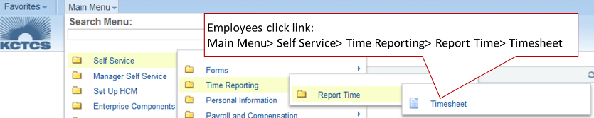
3 | Enter the number of hours you worked for the days that you worked for the semi-monthly pay period (e.g. 8/16/2015 – 8/31/2015).  Overtime will be automatically calculated from the hours you enter. It is not necessary to list how many regular and overtime hours you worked.  Do not enter leave time (vacation, sick, etc.) in this online timesheet). For now, your leave time will continue to be entered and approved using paper timesheets. |  | 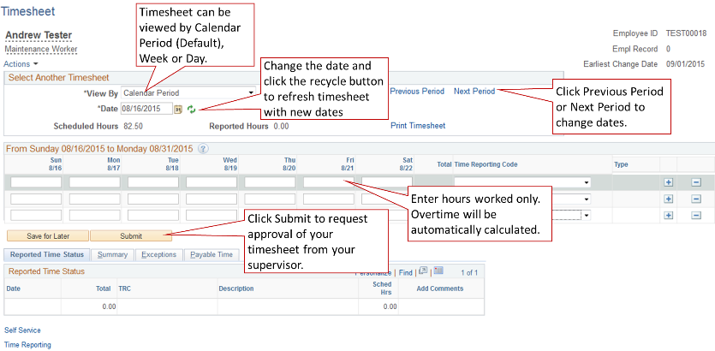  Note: When you first open up a timesheet you will see three rows. Once you save or submit it, it will only show the rows with time in them. Normally, you will only use the top row.
4 | Click Submit to request approval from your supervisor.  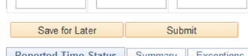 |  | Note: Every time that you click Submit your supervisor will get an email requesting time approval. So, use Save for Later until you are all finished with time entry. Clicking it will not request approval from your supervisor.
5 | Certification of Timesheet:  Click OK once you have submitted your timesheet to certify that the time you entered is accurate. Time can be entered 90 days in the past and 90 days into the future.  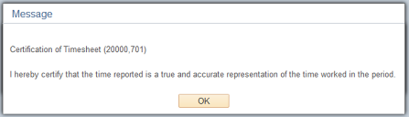 |  | 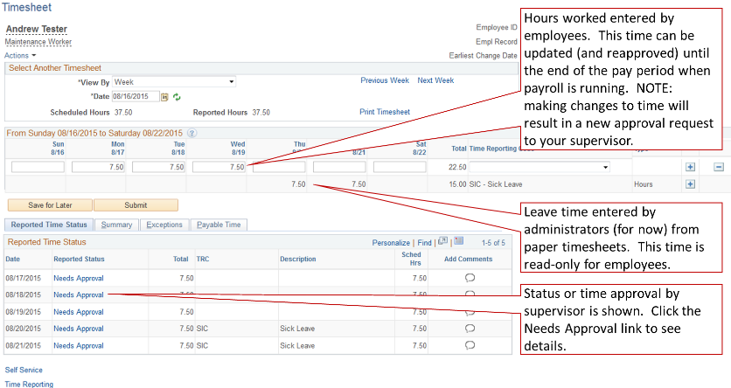
 | Timesheet in  Needs Approval  status or  Approved  status.  For each row of timesheet entry, supervisor can:  (1) Approve, (2) Deny, or (3) Pushback. Pushback works like Deny as configured. | 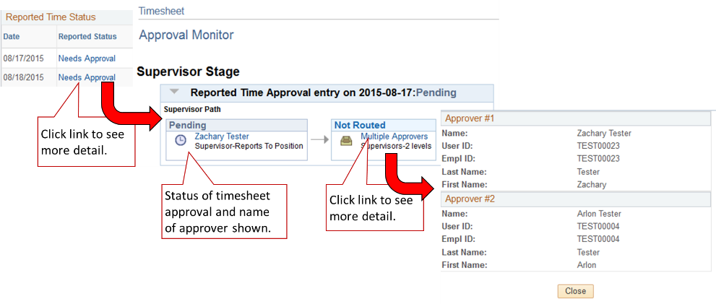
6 | Payable Time:  Time that has been approved is picked up by Payroll’s time administration process and processed.  Time is rounded to the nearest 0.25 hours. (Note that in the example 7.51 has been rounded to 7.50.) | 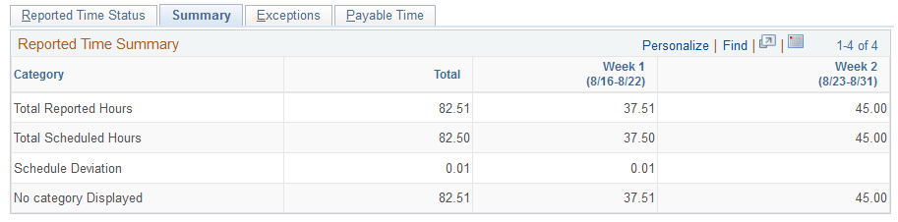  The time administration process takes the time you enter (called “Reported Time” – time entered and approved) and runs it through a number of rules to create what is called “Payable Time” – time that Payroll uses for to create paychecks.
 | Overtime is calculated when Time Admin. process creates Payable Time  This example will create an exception as well that Payroll will need to review as well. | 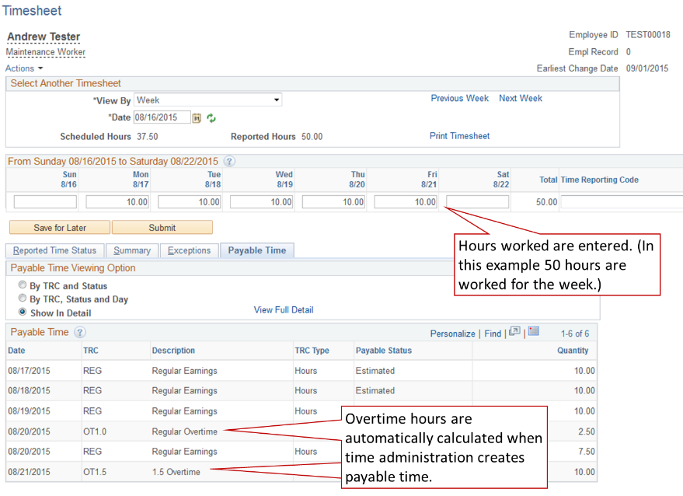
 | Time Reporting Codes:  Time reporting codes (TRCs) are used for automation. You can only use certain TRCs depending on what type of employee you are.  There are a few more TRCs than are shown here, but they are not common.  Employees will see time entered by administrators as “read-only” rows on timesheets. | Time Reporting Codes Entered by Employees:  REG – Regular Earnings  RTW – Ready to Work Grant Funds (Used only by RTW Students)  STU – Student Earnings Code (Used only by Student Workers)  WKS – Work Study Students (Used only by College Work Study Students)  SD2 – Shift Differential 2 ($0.30) (Used only for employees with shift differential)  SD3 – Shift Differential 3 ($0.40) (Used only for employees with shift differential)  Time Reporting Codes Automatically Calculated:  OT1.0 – Regular Overtime (Automatically calculated)  OT1.5 – 1.5 Overtime (Automatically calculated)  Time Reporting Codes Entered by Time Administrators from Paper Leave Requests:  HVA – Hourly Vacation  HTD – Hourly Sick  HBR – Hourly Bereavement Leave  HJD – Hourly Jury Duty  HVL – Hourly Voting Leave  VAC – Vacation Leave  SIC – Sick Leave  BRV – Bereavement Leave  JD – Jury Duty  MIL – Military Leave  Time Reporting Codes with Special Use by Time Administrators:  LOC – Regular with Locality Override  EMC – Emergency Closing  HOL – Holiday Pay (Salaried)  IC – Institutional Close Bonus Days

